Copyright for test papers and marking guides remains with *West Australian Test Papers.*

Test papers may only be reproduced within the purchasing school according to the advertised Conditions of Sale.

Test papers should be withdrawn after use and stored securely in the school until 30 November 2018.



**SEMESTER TWO**

**MATHEMATICS**

**METHODS**

**UNITS 1 & 2**

**2018**

**SOLUTIONS**

***Calculator−free Solutions***

1. (a) 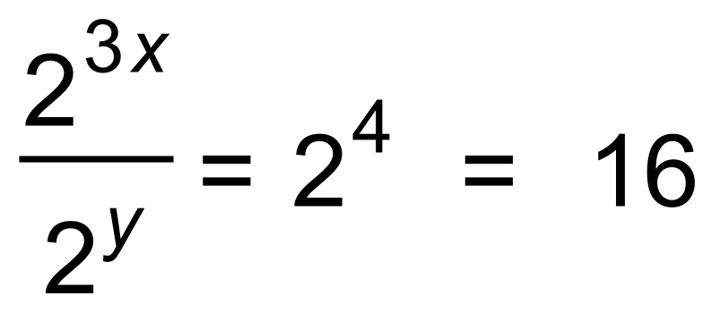 ✓✓

(b) 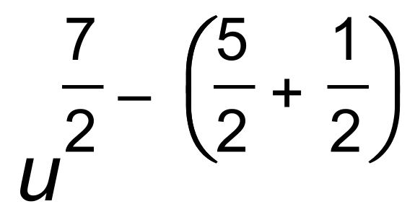 ✓

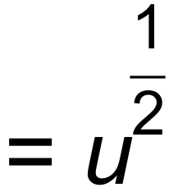 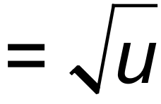 ✓ [4]

2. 

 ✓



 ✓

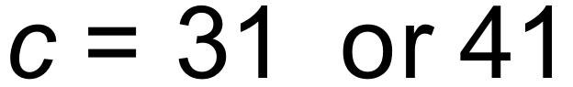 ✓✓ [4]

3. (a) 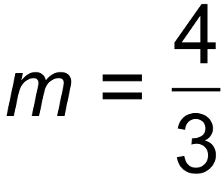 ✓

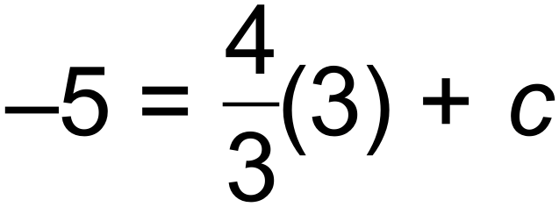

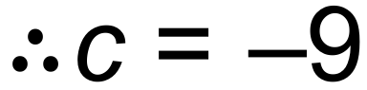 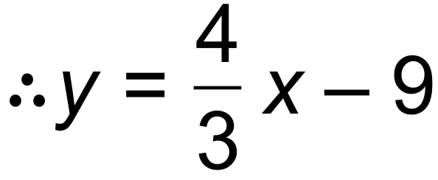 ✓

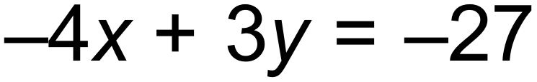 ✓

(b) 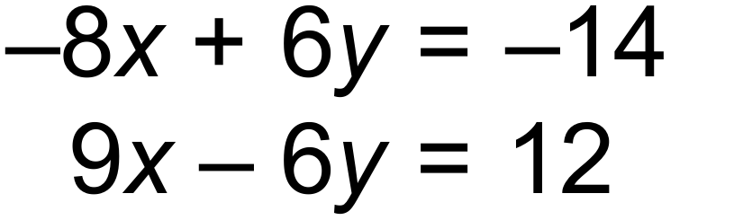

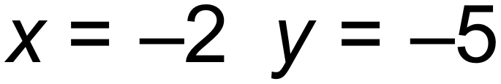 ✓

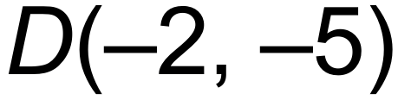 ✓

(c) 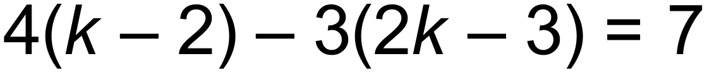 ✓

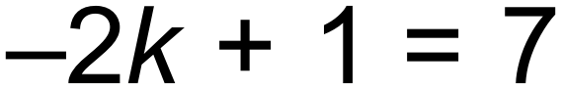

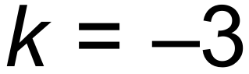 ✓ [7]

4. 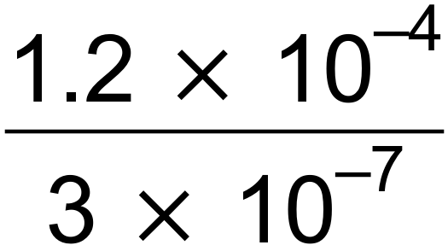 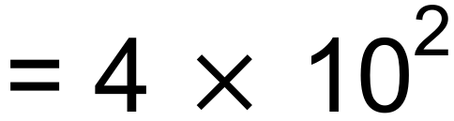 = 400 ✓✓ [2]

5. (a) 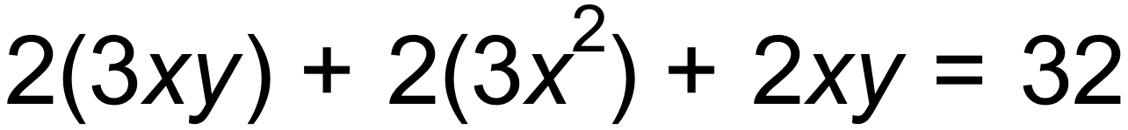 ✓

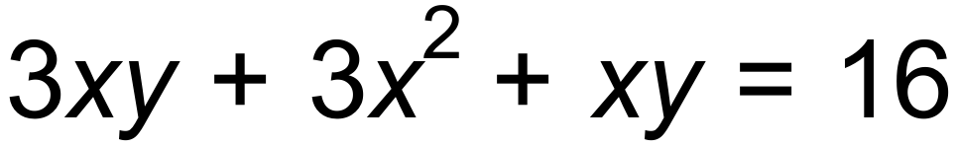 ✓

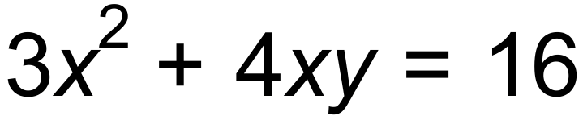

(b) 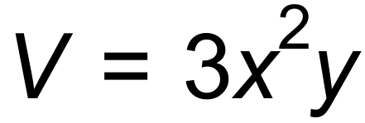 and 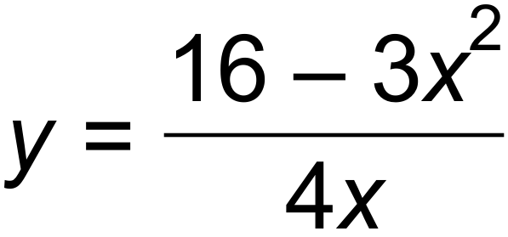 ✓

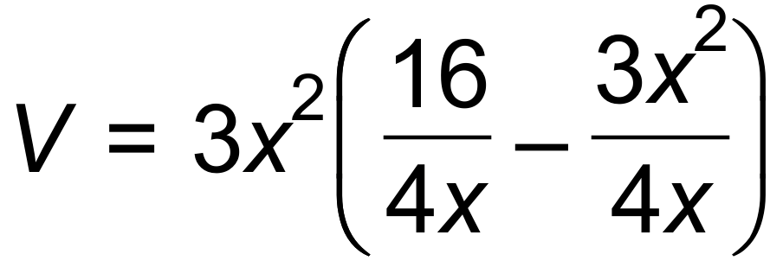 ✓

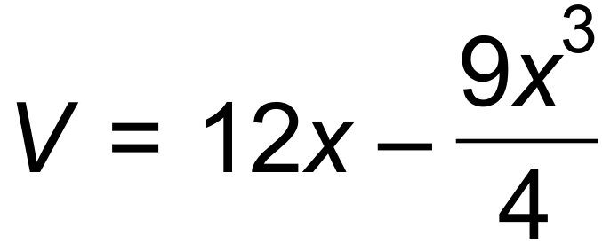

(c) 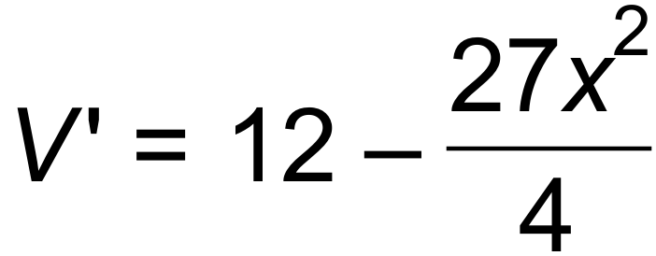

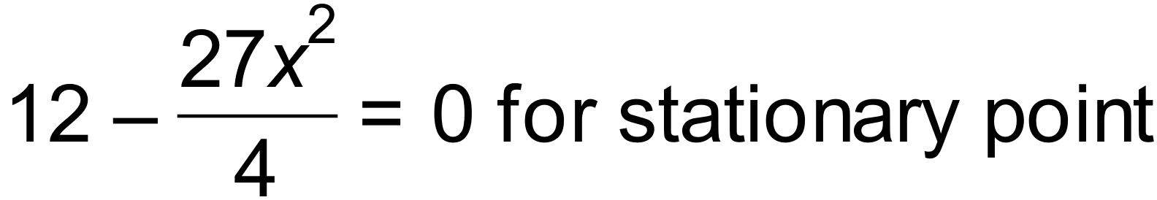 ✓

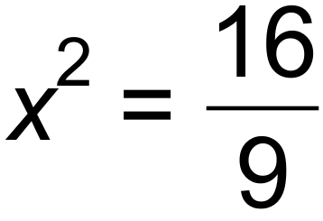 ✓

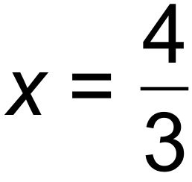 (discard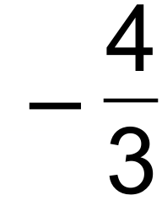 ) ✓

(d)

|  |  |  |  |
| --- | --- | --- | --- |
| V(x) | ↑ |  | ↓ |
| V’(x) | + | 0 |  |

V has a maximum value ✓✓ [9]

6. (a) Tn+1 = Tn +10 T1 = 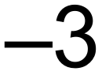 ✓✓

(b) T2 = 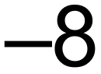 ✓

T3 = −32 ✓ [4]

7. (a) 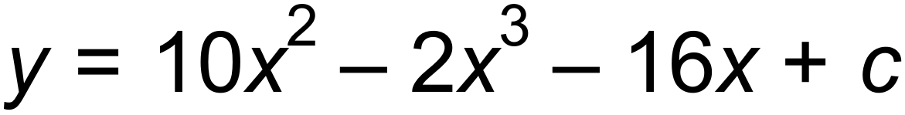 ✓

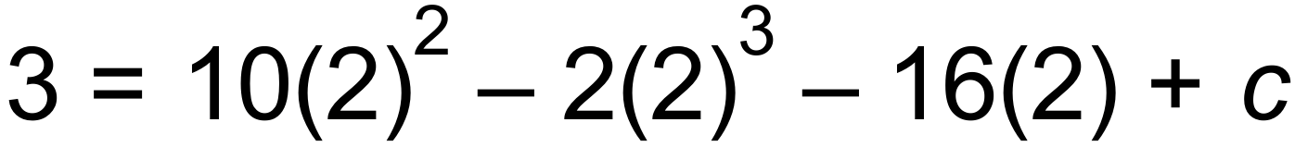 ✓

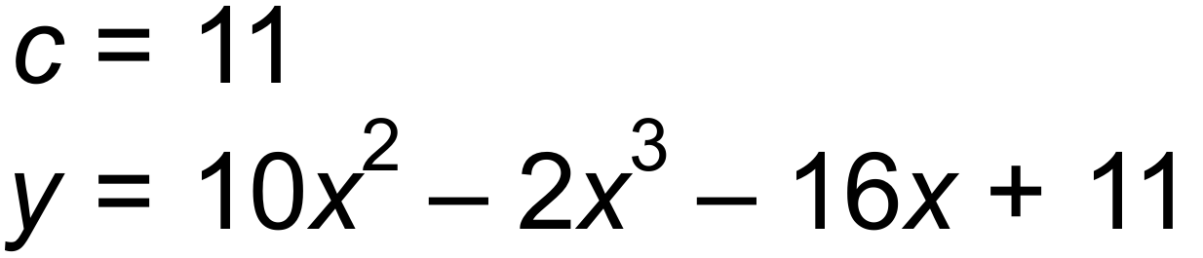 ✓

(b) Gradient of xaxis = 0

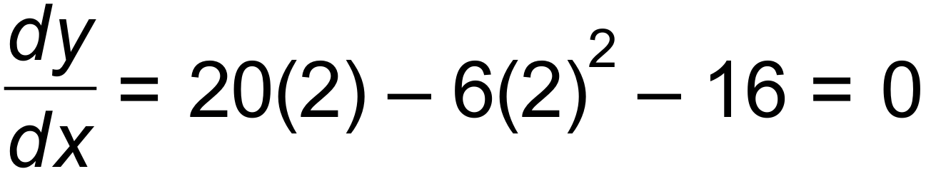 ✓

 Tangent is horizontal and parallel to the xaxis. ✓ [5]

8. (a) Vertical translation 12 units down ✓

Horizontal dilation by factor . ✓

(b) 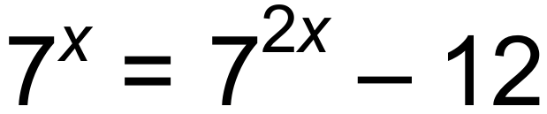

Let 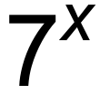 be k. 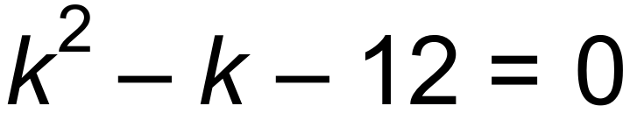 ✓

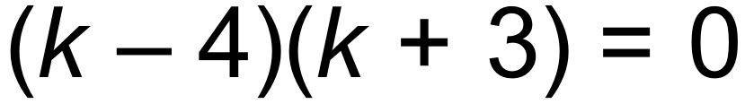 ✓

 ✓

One solution, therefore intersects at only one point. [5]

9. (a) 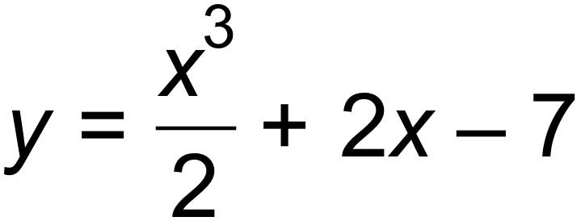 ✓

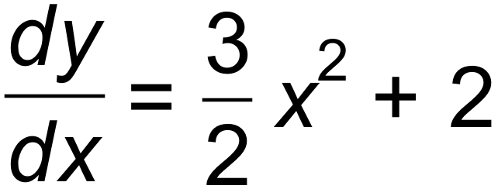 ✓

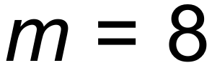 ✓

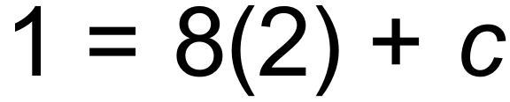

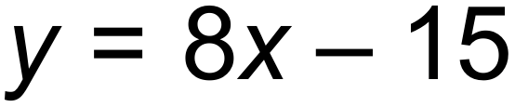 ✓

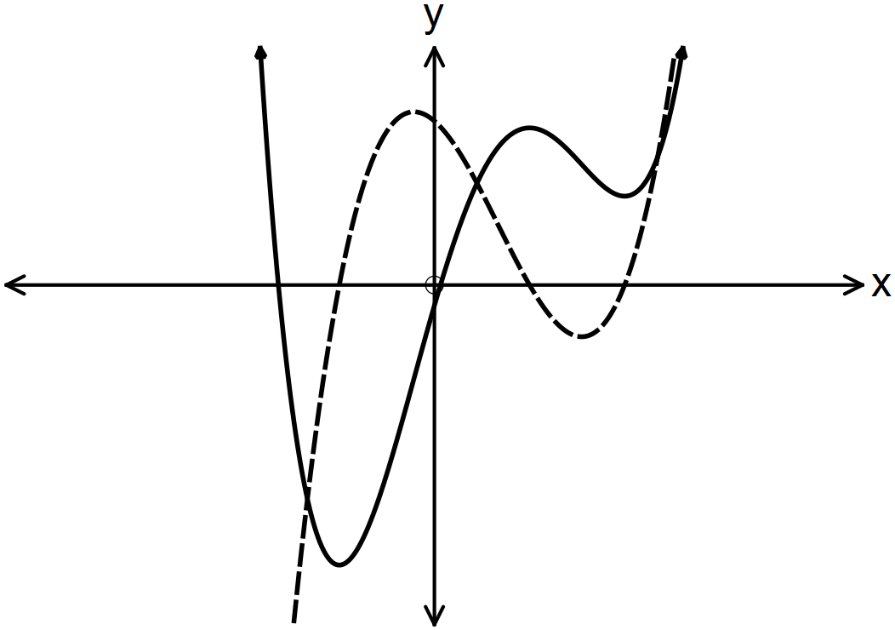 (b)

✓✓ [6]

10. (a) Period 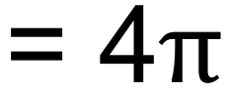 ✓

Amplitude = 2 ✓

(b)

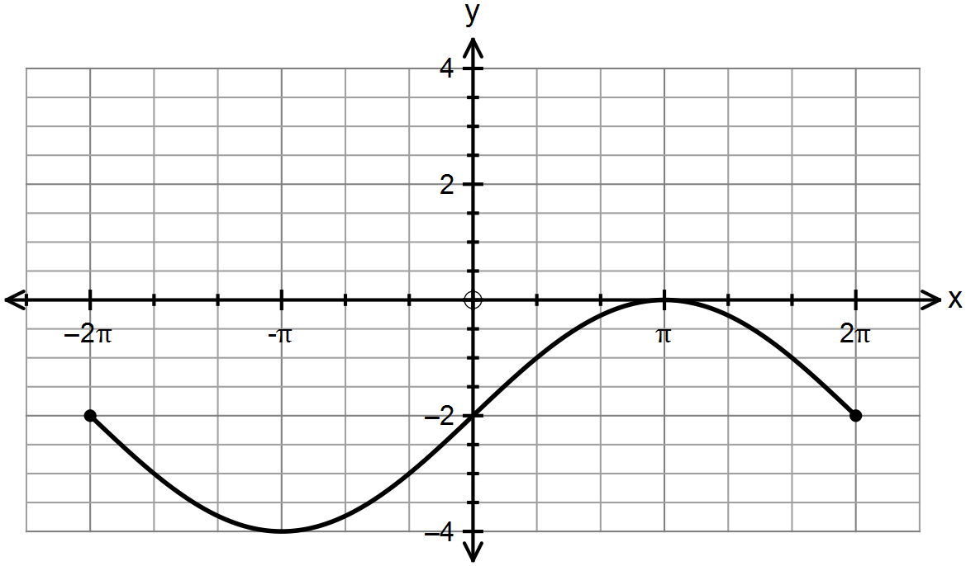

✓✓✓ [5]

***Calculator−assumed Solutions***

11. (a) The number of phones she is given to repair for the week. ✓

(b) She fixes 23 per day, for 4 days 23 x 4 = 92 phones ✓

(c) 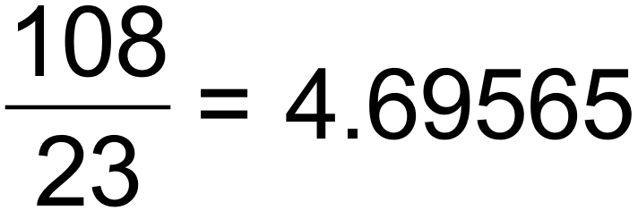 days ✓

 hours

5 hours and 34 minutes ✓

(d) T1 =155 T2 = 128 T3 = 99 T4 =68

Tn+1 = Tn – (25 +2n) T0 = 180 ✓✓ [6]

12. (a) 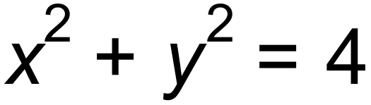 ✓

(b)  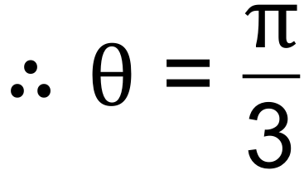 radians ✓

radius = 2 units ✓

(c) 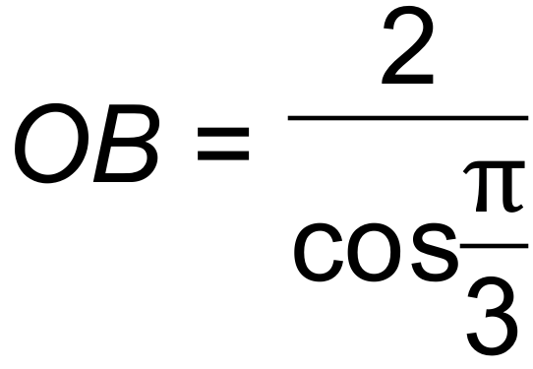 = 4

Therefore area of ΔAOB = 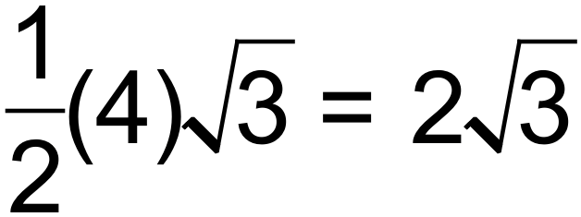 units2 ✓

Area of sector = 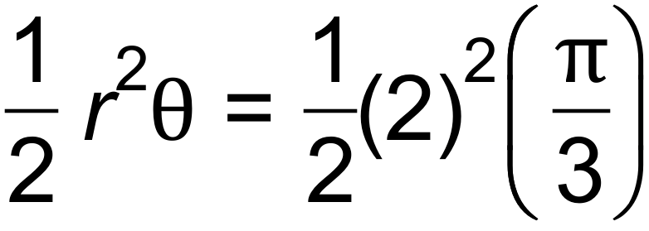

= 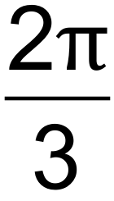 units2 ✓

Area of shaded part = triangle – sector

= 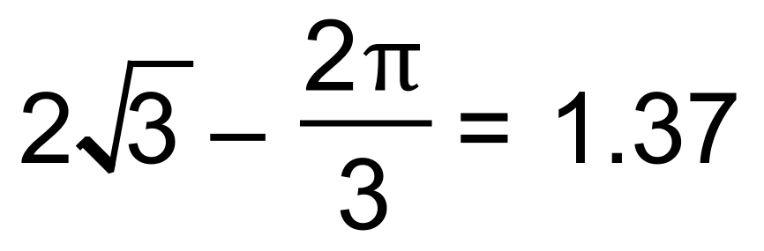units2 (3 sig fig) ✓ [6]

13. (a) 5.1 seconds ✓

(b) 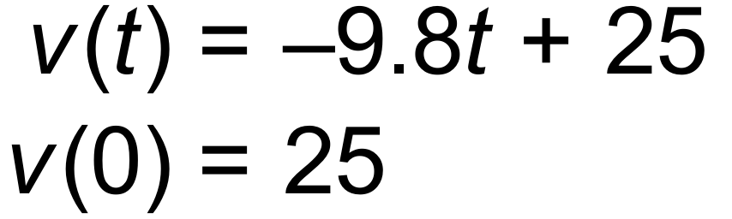 ✓✓

(c) Maximum height is 31.89 m when 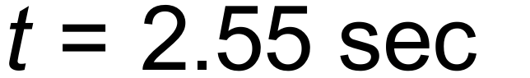

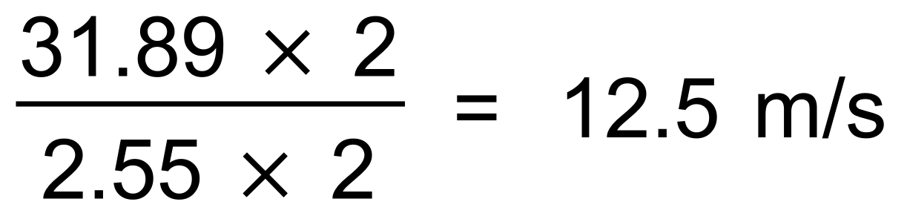 ✓✓ [5]

14. (a) 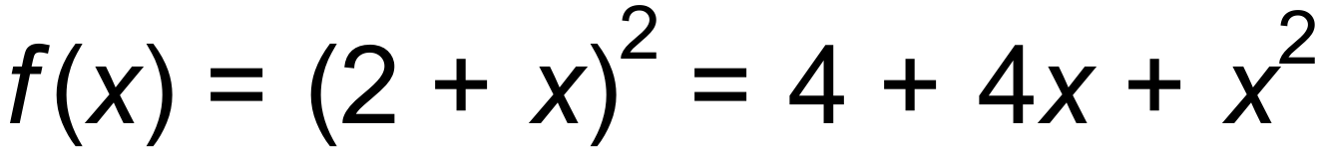 ✓

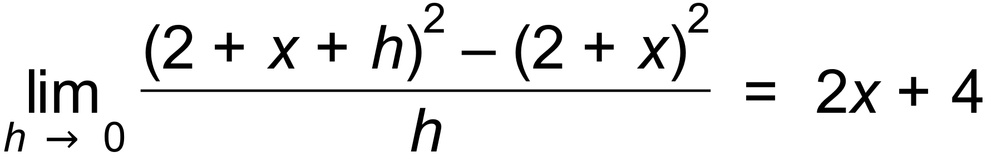 ✓

(b) (i) 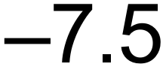 ✓

(ii) 18 ✓

(c) 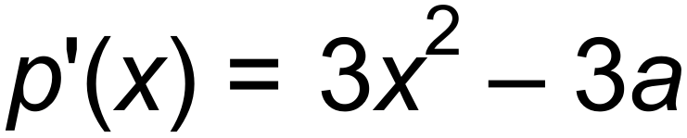 ✓

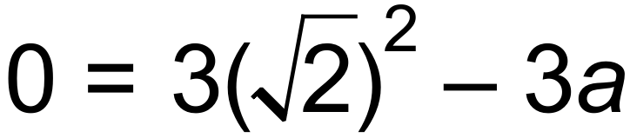

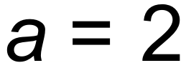 ✓

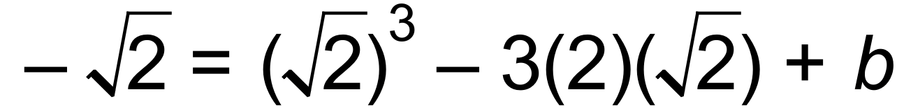

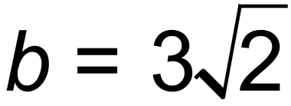 ✓ [7]

15. (a) 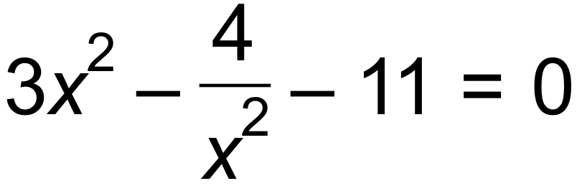

 ✓✓

|  |  |  |  |  |  |
| --- | --- | --- | --- | --- | --- |
|  |  |  |  | 2 |  |
|  | + | 0 |  | 0 | + |
| y | ↑ | - | ↓ | - | ↑ |

(b)

✓✓

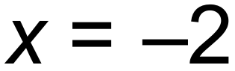 Maximum

 Minimum ✓

(c) 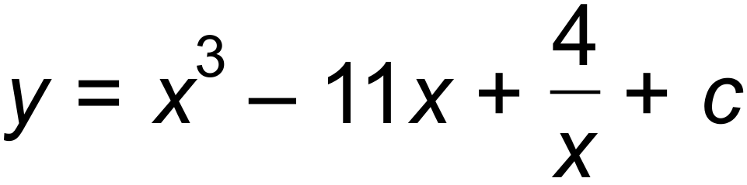 ✓

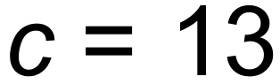

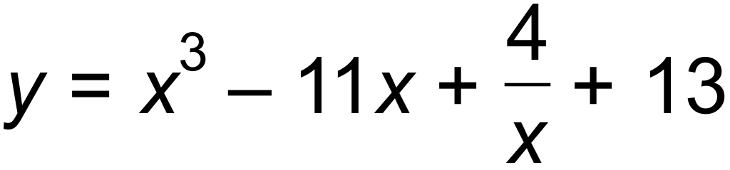 ✓

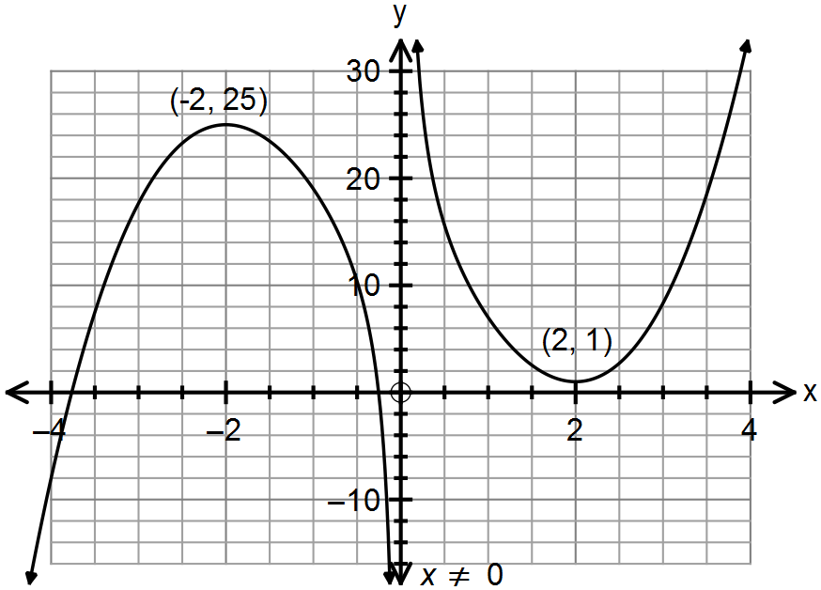(d)

✓✓✓ [10]

16. (a) (i) T100 = 23 +(99)(9) ✓

= 914 ✓

(ii) 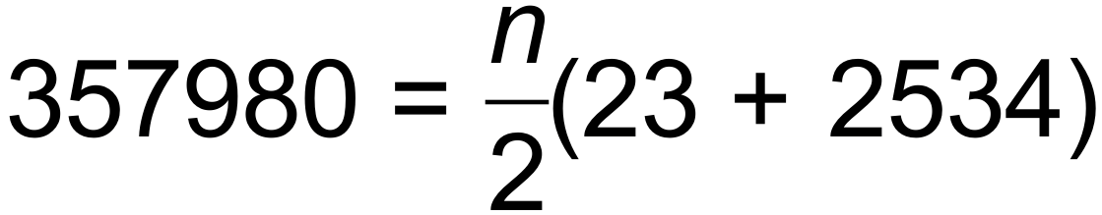 ✓

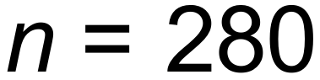 ✓

(b) (i) Tn+1 = Tn T1 = 12 ✓✓

(ii) 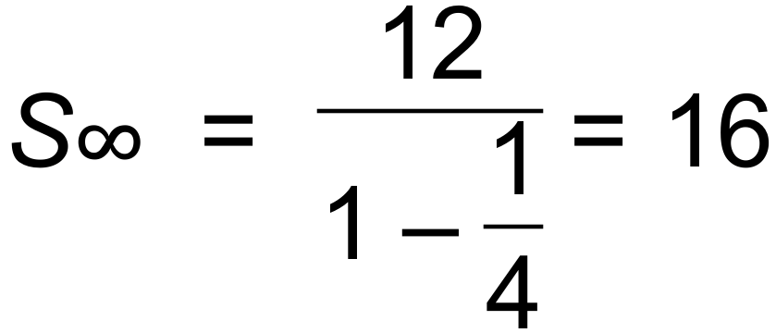 ✓✓ [8]

17. (a) 92°C (initial temp of tea) ✓

22°C (room temp) ✓

(b) After 4.12 mins and before 7.45 mins ✓✓

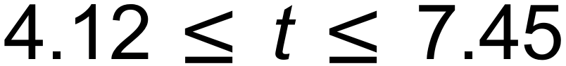

(c) Horizontal asymptote 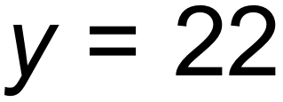 ✓

The tea will cool at a decreasing rate as it approaches room

temperature which is 22°. ✓ [6]

18. (a) 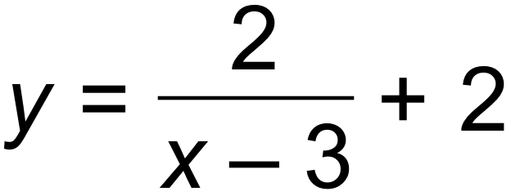 ✓✓

(b) 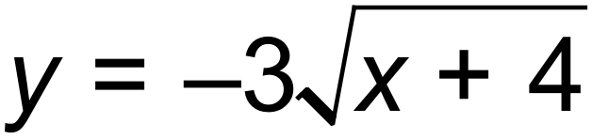 ✓✓

(c) 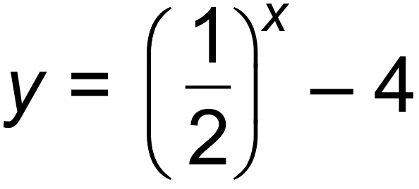 ✓✓ [6]

19. (a) 0.2 ✓

(b) 0.5 ✓

(c) 0.3 ✓

(d) Pr(X  Y) = Pr(X) x Pr(Y) if independent

Pr(X  Y) = Pr(X) + P(Y) - Pr(X  Y) ✓

Pr(X) + Pr(Y) - Pr(X  Y) = Pr(X) x Pr(Y) ✓

Let Pr(Y) = k

0.5+ k - 0.8 = 0.5k

k = 0.6 = Pr (Y) ✓ [6]

20. (a) 1, 3, 7, 15,…

Tn+1 = Tn + 2n T1 = 1 ✓✓

(b) 20 sets ✓ [3]

21. (a) (i) 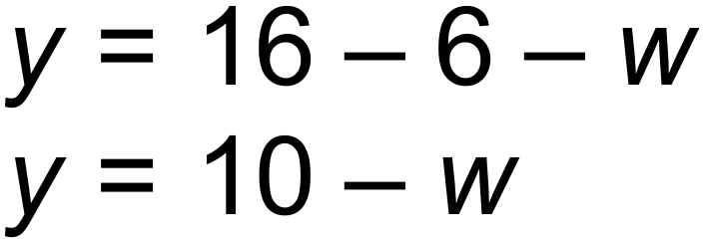 ✓

(ii) 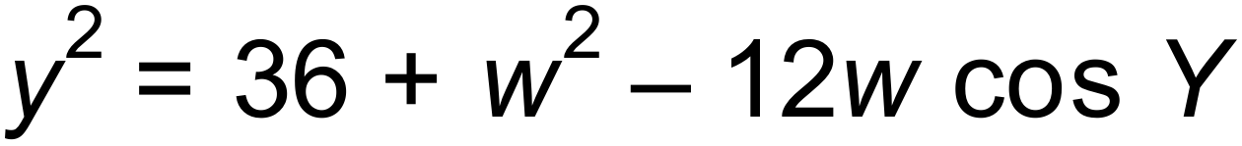 ✓

(iii)  ✓

 ✓

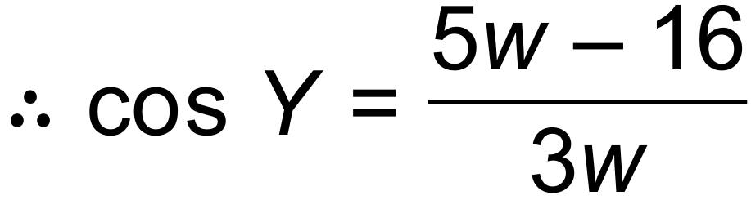

(b) (i) 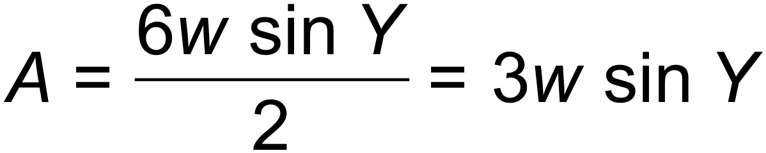 ✓

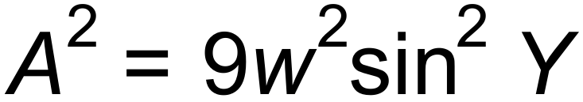 ✓

(ii) 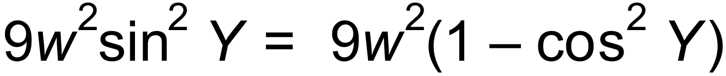 ✓

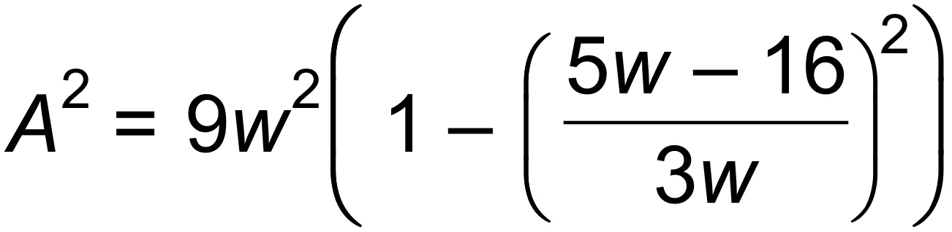 ✓

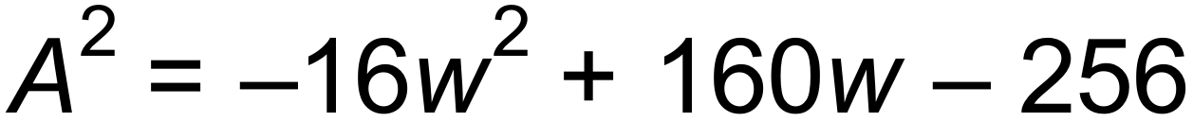 ✓

(c) (i) 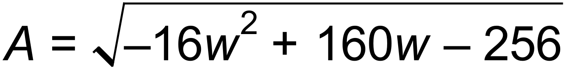

 ✓

Maximum area = 12 units2 ✓

(ii) 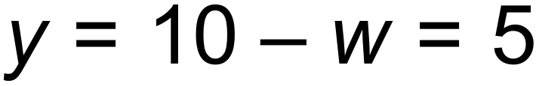

The triangle is isosceles. ✓ [12]

22. 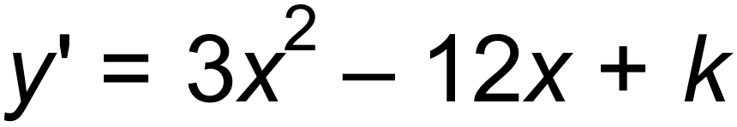 ✓

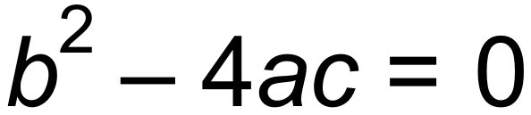 for one solution

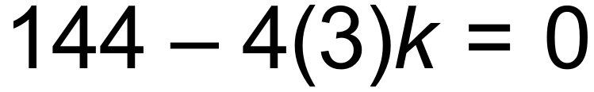 ✓

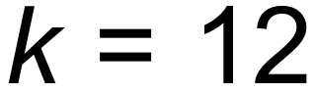 ✓ [3]

23. (a) W = W0 (1.085)t

R = R0 (0.95)t

10W0 = R0

W0 (1.085)t = 10 x W0 (0.95)t ✓

(1.085)t = 10(0.95)t

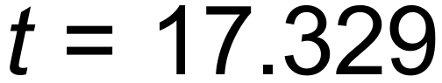 years ✓

After 18 years there will be more wallabies. ✓

(b) Wn+1 = 1.085 Wn W0 = 655 ✓

W5 = 985 ✓ [5]

24. (a) 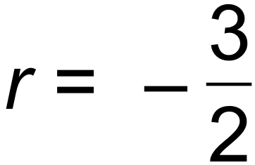 ✓

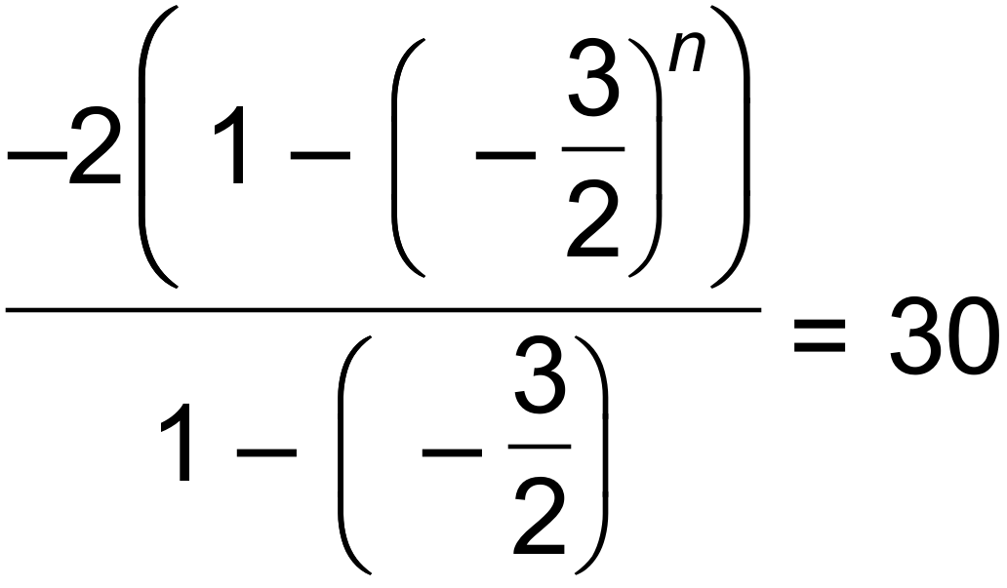  ✓

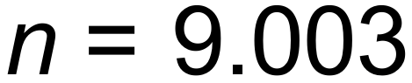

 ✓

(b) T5 = 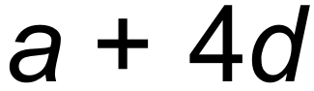 and T7 = 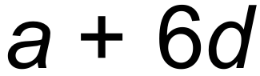

 (eq 1) ✓

S15 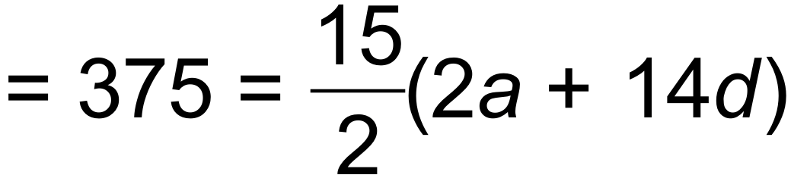 (eq 2) ✓

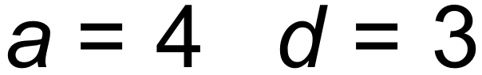 ✓

S30 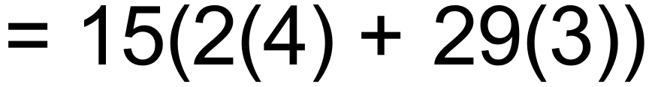 = 1425

Sum of next 15 terms = S30  S15 = 1050 ✓ [7]

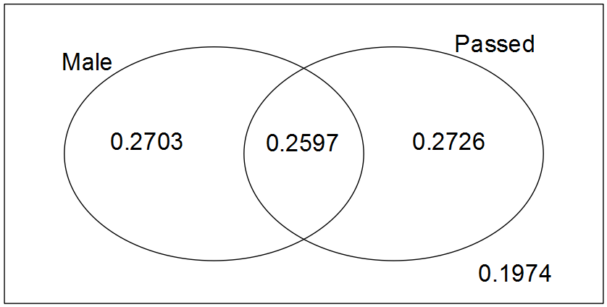25. (a)

✓✓✓

(b) (i) 0.5323 ✓

(ii) 0.2726 ✓

(iii) 0.51 ✓

(iv) 0.8026 ✓ [7]

26. The particle’s initial displacement is 5 m to the right of the origin. ✓

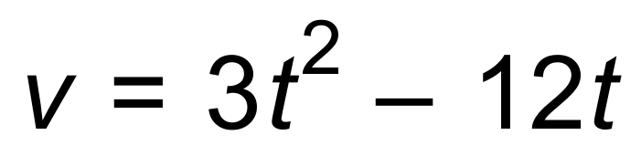 ∴ Initial velocity = 0 ✓ [2]